Installing VIA onto your Servite device

- Go onto Google Chrome/ Safari/ Mozilla/ Microsoft Edge or any other web browser and type the following link in the URL:
via.servite.wa.edu.au

- Click on the “Install Via” button.

- This will then pop up and once it has loaded click on it. This will then open the VIA app and you can start using it. 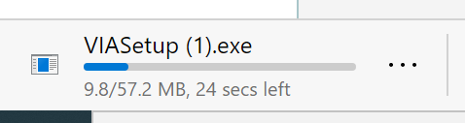

- The VIA app looks like one of these:

